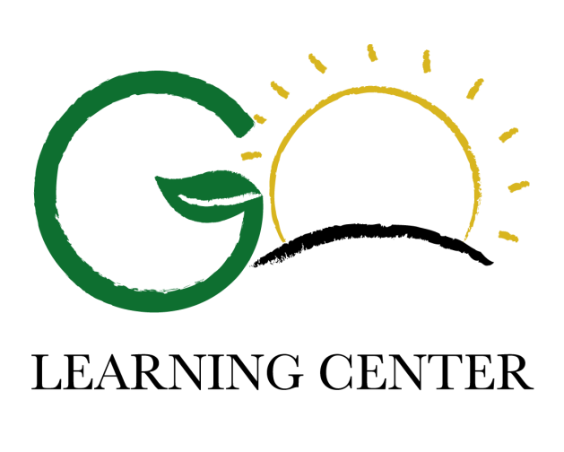

항상 아이들을 저희에게 믿고 맡겨주시는 학부모님들께 감사드리며 자세한 정보 또는 궁금하신점 있으신 분들은 아래 연락처로 연락 주시면 감사하겠습니다.
Go Learning Center
Phone : 267-945-6554
KakaoTalk : golearning
Website : www.golearningcenter.com

Office Hours :
Monday-Thursday 4:00pm to 7:00pm
Friday Closed
Saturday 9:00am to 3:30pm
Sunday Closed

Go Learning Center 2015-2016

Winter Programs

Middle School Class Schedule
Monday |  |  | Tuesday |  |  | Wednesday |  |  | Thursday
4:00pm | Writing I | Algebra II |  | Reading II | Geometry |  | Writing I | Algebra II |  | Reading II | Geometry
6:00pm | Reading 1 |  |  | Writing II | Algebra I |  | Reading I |  |  | Writing II | Algebra I
8:00pm | Book Club 8th-10th | Book Club 5th-6th |  | Book Club 7th-8th |  |  |  |  |  |  | Math Club
9:30pm

Classes and Services
- SAT Course : 토 (9:00-3:30) 1/9 – 2/27 (8 Weeks)
- Enrichment Class : 월,수 또는 화,목 (4:00-5:30 또는 5:30-7:00)
- Writing Class 1, 2 : 월,수 (4:00-5:30) 화,목 (5:30-7:00) 1/4 – 3/21 (12 Weeks)
- Reading Class 1, 2 : 월,수 (5:30-7:00) 화,목 (4:00-5:30) 1/4 – 3/21 (12 Weeks)
- Algebra I Part.A Class : 화,목 (5:30-7:00) 1/5 – 3/22 (12 Weeks)
- Algebra II Part.A Class : 월,수 (4:00-5:30) 1/5 – 3/22 (12 Weeks)
- Geometry Part.A Class : 월,수 (4:00-5:30) 1/4 – 3/21 (12 Weeks)
- Book Club : 5-6학년 7-8학년 : 화 (7:30-9:00), 9-10 학년 : 월 (7:00-8:30)
- Math Club : 목 (7:00-8:30)
- 대학 진로상담, 학비 지원상담, 그리고 입학 Essay
- 과목별 개인과외

